**Machine Learning Business Report**

V1.0

**Prepared by: Lavanya Sreeram**

**Prepared for:** GL Batch Nov 22

May 27, 2023

### Document Information

|  |  |
| --- | --- |
| **Author:** | Lavanya Sreeram |
| **Document Title** | Lavanya_Sreeram_29_05_2023 |
| **Issue Date:** | 29-05-2023 |
| **Version:** | V 1.0 |
| **Subject:** | Machine Learning Business Report by Lavanya Sreeram |

### Revision History

|  |  |  |  |
| --- | --- | --- | --- |
| **Version** | **Date** | **Revised By** | **Reason** |
| 1.0 | 29-05-2023 | Lavanya Sreeram | First Issue |
|  |  |  |  |
|  |  |  |  |

### Contents

Document Information 1

Revision History 1

Contents 2

1 Problem 1: Linear regression 9

Data Description 9

1.1 Exploratory Data Analysis 9

1.1.1 Data Exploration 9

1.1.2 Univariate Analysis: 11

1.1.3 Bivariate Analysis 19

1.2 Data Preparation 20

1.2.1 Null Values 21

1.2.2 Encode Data 22

1.2.3 Outliers 23

1.2.4 Co-relation 24

1.2.5 Scaling 29

1.3 Create Models 30

1.3.1 Split Data 30

1.3.1.1 VIF (Variance Inflation Factor) 31

1.3.2 Model 1 – OLS Initial 32

1.3.3 Model 2 – OLS Dropped p>.05 33

1.3.4 Model 3 – OLS Scaled Data 34

1.3.5 Model 4 – OLS Scaled and refined 35

1.3.6 Model 5 – OLS Data – dropping variables 36

1.3.7 Model 6 – Simple Linear Regression 38

1.3.7.1 Actual v predicted scatter plot 39

1.3.7.2 Residual plot 39

1.3.8 Model 7 – Linear Regression on Scaled Data 40

1.3.9 Model 8 – Linear Regresion on Scaled data- dropping features over VIF 5 41

1.3.10 Scikit learn Linear Models Discussion & Equation 41

1.3.11 Compare Scikit learn and OLS model – Model 5, Model 6 42

1.4 Inference 42

2 Problem 2: Logistic Regression, LDA, CART 43

Data Description 43

2.1 Exploratory Data Analysis 43

2.1.1 Sample Data 44

2.1.2 Data Statistical Description 44

2.1.3 Missing Values 45

2.1.4 Univariate Analysis 47

2.1.5 Bivariate Analysis 60

2.1.6 Encode data 63

2.1.7 Outliers 66

2.2 Prepare Data & Create Models 67

2.2.1 Encode data 67

2.2.2 Co-relation 67

2.2.3 Split Data 69

2.2.4 Model 1 – Decision Tree 70

2.2.5 Model 2 – Apply Logistic, LDA, Cart 71

2.2.6 Model 3 – Apply Logistic, LDA, CART on binned data 72

2.3 Performance Metrics 78

2.3.1 ROC Curve, Classification Report, Confusion Matrix 78

2.3.2 Accuracy & ROC 84

2.4 Inference 84

2.4.1 Model Discussion 84

2.4.2 Business Recommendations: 84

3 Reflection Report: 86

Figures:

|  |  |  |
| --- | --- | --- |
| Figure No | Description | Pg No |
| 1.1.1 | Firm Data top 5 observations – as given | 10 |
| 1.1.2 | Firm Data bottom 5 observations – as given | 11 |
| 1.1.3 | Firm Data description - initial | 11 |
| 1.1.4 | Firm data after dropping ‘Unnamed:0’ feature | 11 |
| 1.1.5 | Firm data statistical description -initial | 12 |
| 1.1.6 | Histogram and countplot of the firm data | 20 |
| 1.1.7 | Firm data - Pairplot | 21 |
| 1.2.1 | tobinq’ boxplot | 22 |
| 1.2.2 | Firm Data Info after null values are treated | 23 |
| 1.2.2.1 | Firm Data after encoding | 23 |
| 1.2.2.2 | Firm Data after converting datatype | 23 |
| 1.2.3.1 | Firm Data boxplot showing outliers | 24 |
| 1.2.3.2 | Firm Data Boxplot after treating outliers | 25 |
| 1.2.4.1 | Heatmap – of all variables - before outliers | 26 |
| 1.2.4.2 | Heatmap – of independent variables - before outliers | 27 |
| 1.2.4.3 | Heatmap – of all variables - after treating outliers | 28 |
| 1.2.4.4 | Heatmap – of independent variables - after treating outliers | 29 |
| 1.2.5.1 | Firm Data after scaling | 30 |
| 1.3.1.1.1 | Variance Inflation Factor on ols train dataset | 32 |
| 1.3.1.1.2 | Variance Inflation Factor on scaled ols train dataset | 33 |
| 1.3.2 | Model 1 – OLS Initial Model | 34 |
| 1.3.3 | Model 2 – OLS Model dropped p>.05 | 35 |
| 1.3.4 | Model 3 – OLS Initial Model on scaled data | 36 |
| 1.3.5 | Model 4 – OLS Model on scaled data dropped p>.05 | 37 |
| 1.3.6 | Model 5 - OLS Improved model | 38 |
| 1.3.7.1 | Scatter plot -Actual v Predicted Sales for OLS Stats model | 40 |
| 1.3.7.2 | Residual Plot OLS Stats Model | 41 |
| 2.1.1.1 | Sample Crash Data top 5 | 45 |
| 2.1.1.2 | Sample Crash Data bottom 5 | 45 |
| 2.1.1.3 | Sample Crash Data top 5 -(Dropped unnamed, caseid) | 45 |
| 2.1.2.1 | Crash Data Description 1 | 46 |
| 2.1.2.2 | Crash Data Description 2 | 46 |
| 2.1.3.1 | Crash Data info-Missing values treated | 47 |
| 2.1.3.2 | Boxplot showing ‘injSeverity’ skewedness | 47 |
| 2.1.4 | histograms & Countplots of Crash data | 61 |
| 2.1.5.1 | Year Of Accident v Survival | 62 |
| 2.1.5.2 | Year of Vehicle on barplot with Survived as hue | 63 |
| 2.1.5.3 | Pairplot of Crash data | 64 |
| 2.1.6.1 | Crash data info after Encoding. | 65 |
| 2.1.6.2 | Crash data sample observation after Encoding | 65 |
| 2.1.6.3 | Crash data statistical description after Encoding | 66 |
| 2.1.7.1 | Boxplot showing Crash Data outliers | 67 |
| 2.1.7.2 | Boxplot showing Crash Data after treating outliers | 68 |
| 2.2.1.1 | Crash data info after Encoding. | 68 |
| 2.2.2.1 | HeatMap showing Crash data correlation | 69 |
| 2.2.3.1 | Crash data- Train Data sample | 70 |
| 2.2.3.2 | Crash data- Test Data sample | 70 |
| 2.2.3.3 | Crash data- Train Data sample after binning | 71 |
| 2.2.3.4 | Crash data- Test Data sample after binning | 71 |
| 2.2.4.1 | Model -1 Decision Tree basic | 71 |
| 2.2.4.2 | Importance of Features | 72 |
| 2.3.2 | Crash Data Regression Performance Metrics – Accuracy & ROC | 85 |

Tables:

Table1 VIF Range Page-33

# Problem 1: Ensemble Techniques

You are hired by one of the leading news channels CNBE who wants to analyze recent elections. This survey was conducted on 1525 voters with 9 variables. You have to build a model, to predict which party a voter will vote for on the basis of the given information, to create an exit poll that will help in predicting overall win and seats covered by a particular party.

## Data Description

[Election_Data.xlsx](https://olympus.mygreatlearning.com/courses/87097/files/8138804/download?verifier=CGu44yb3X3sOTOswXQzIQEOQ8SkF5SQLqHa50fzO&wrap=1) data set is provided. Data Dictionary for Election_Data is as below:

1. vote: Party choice: Conservative or Labour

2. age: in years

3. economic.cond.national: Assessment of current national economic conditions, 1 to 5.

4. economic.cond.household: Assessment of current household economic conditions, 1 to 5.

5. Blair: Assessment of the Labour leader, 1 to 5.

6. Hague: Assessment of the Conservative leader, 1 to 5.

7. Europe: an 11-point scale that measures respondents' attitudes toward European integration. High scores represent ‘Eurosceptic’ sentiment.

8. political.knowledge: Knowledge of parties' positions on European integration, 0 to 3.

9. gender: female or male.

## Exploratory Data Analysis

Read the dataset. Describe the data briefly. Interpret the inferences for each. Initial steps like head() .info(), Data Types, etc . Null value check, Summary stats, Skewness must be discussed.

Answer:

### Data Exploration

The Dataset has 759 rows, 10 columns. ‘sales’ is the Target Variable. The below snap shows the dataset first 5 observations.

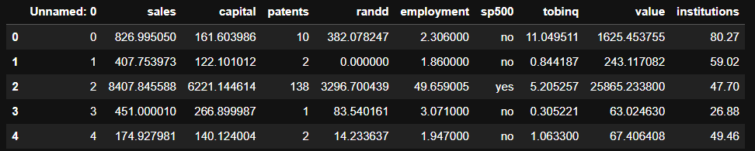

Fig1.1.1 Firm Data top 5 observations – as given

The below snap shows the bottom 5 observations.

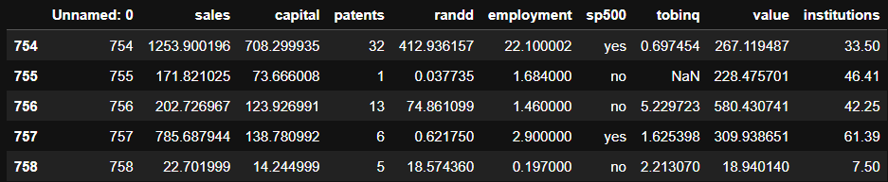

Fig1.1.2 Firm Data bottom 5 observations – as given

On first look, it can be inferred that the feature ‘Unnamed: 0’ must be dropped. Additionally, it can be noted that the data is not scaled.

The below snap shows the datatypes of all features of the dataset.

(Fig1.1.3): Firm Data description - initial

Except ‘sp500’, all the features in the data are numeric in nature ('int64' or 'float64' type). ‘sp500’ is object type, and as per data dictionary the feature is binary. ‘sp500’ shall be encoded.

Drop ‘Unnamed:0’ feature. Now, the dataset top 5 observations are as shown below:

(Fig 1.1.4): Firm data after dropping ‘Unnamed:0’ feature

The statistical data descriptions is as shown in below snap.

(Fig1.1.5): Firm data statistical description -initial

### Univariate Analysis:

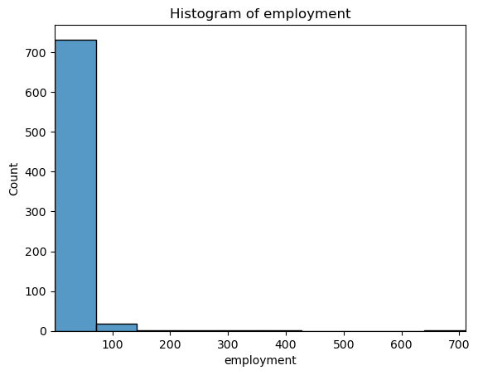

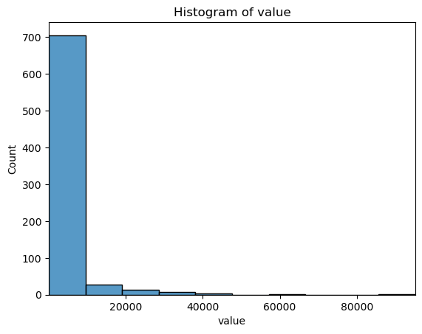

All the above histograms show that the data is right skewed or positively skewed meaning that the mean is greater than the median. This is because the presence of a few large values on the right pulls the mean towards higher values. The tail of the distribution extends towards larger values, indicating the presence of outliers or extreme values on the right side. This can happen as few observations in ‘sales’ or ‘value’ are significantly higher in weight/value compared to the majority. This is generally the case with economic observations like stock prices.

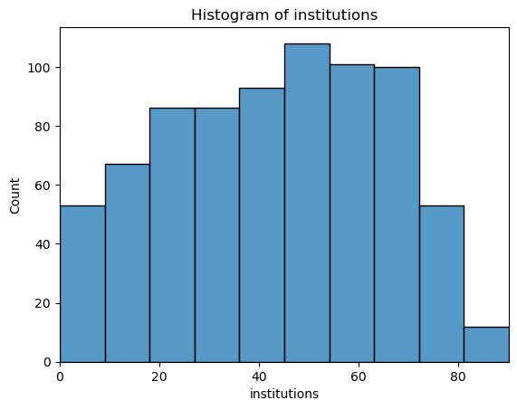

From the above histogram, it can be noted that the ’institutions’ is not as skewed as rest of the features. In fact, the feature is more uniform and has left skewedness in data.

Count plot is used for the binary variable ‘sp500’ as shown below:

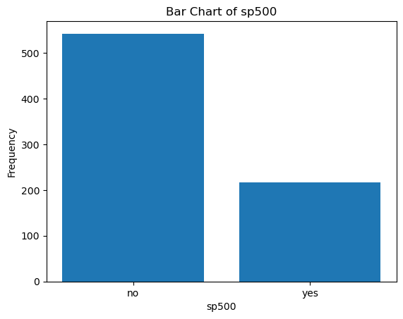

Fig1.1.6 Histogram and countplot of the firm data

The plot shows that the observations with S&P 500 index companies are less in number compared to opposite.

### Bivariate Analysis

Bivariate analysis is performed on the data and the pair plot is shown below:  
Fix- highlight co-relation features.

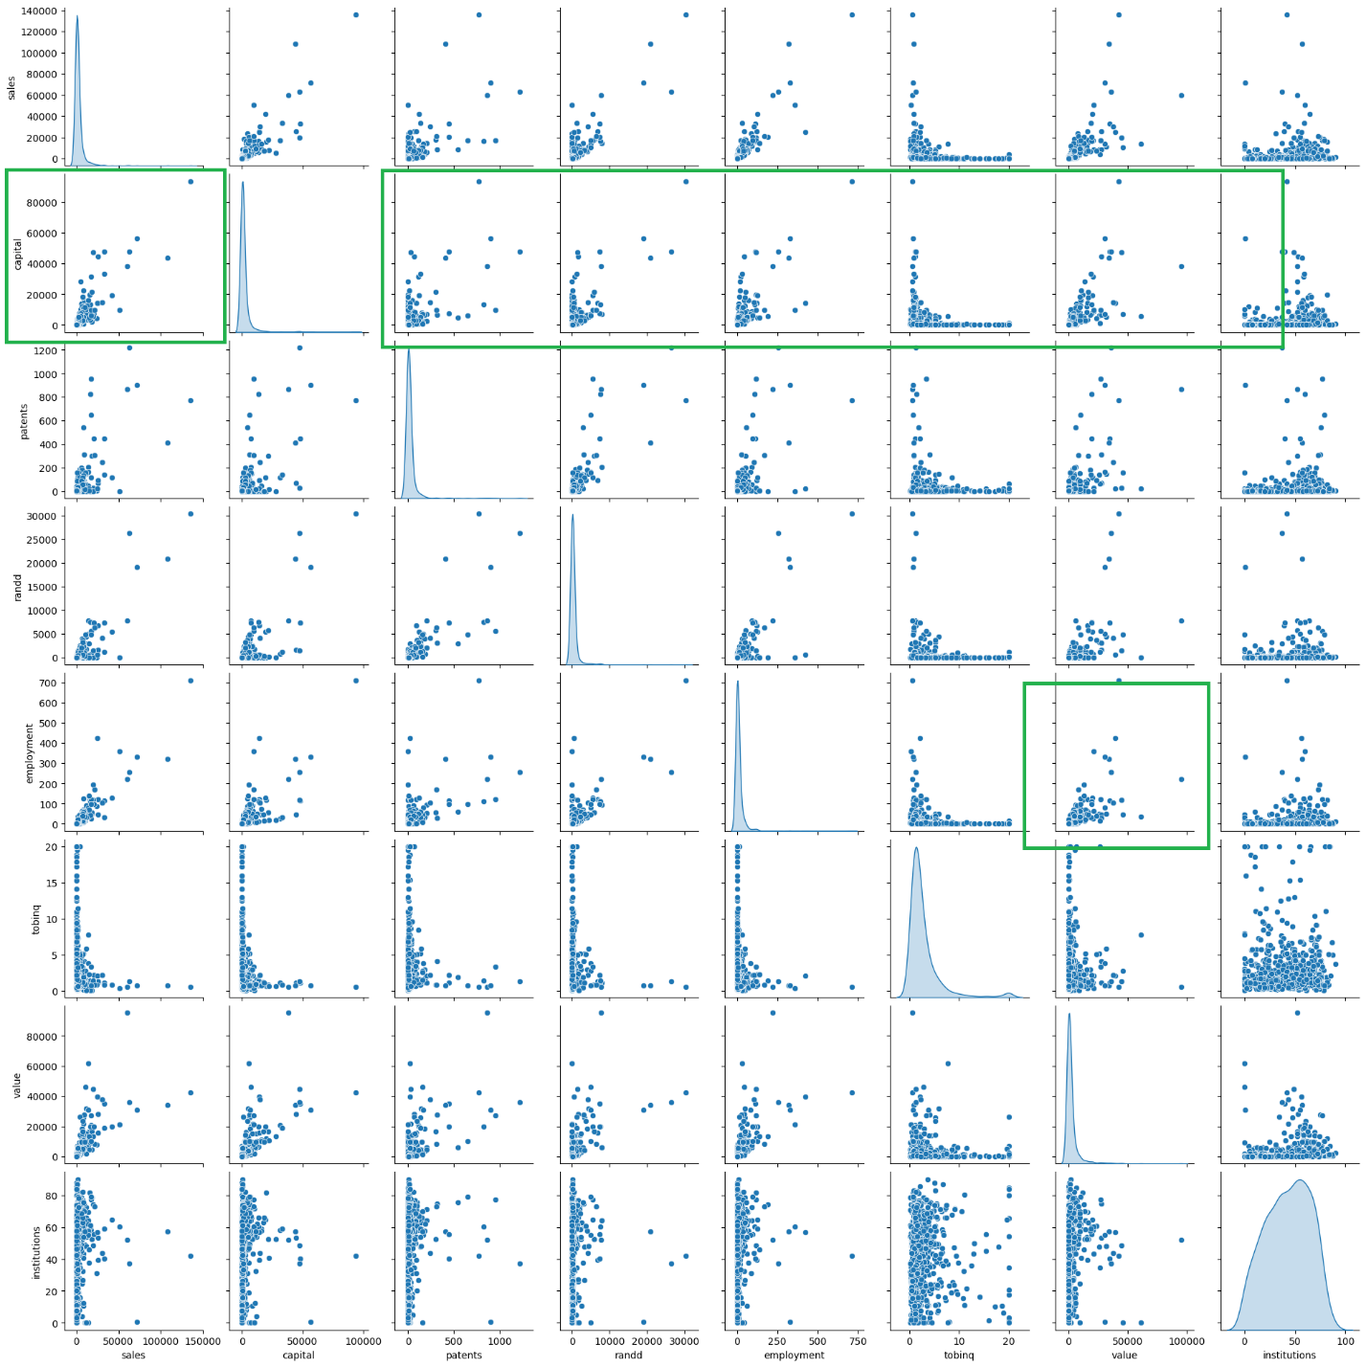  
(Fig 1.1.7): Firm data – Pairplot

There is lot of positive high correlation & linear relationship for ‘capital’ variable with multiple variables. Similar insights are drawn from the heatmap.

## Data Preparation

Perform EDA (Check the null values, Data types, shape, Univariate, bivariate analysis). Also check for outliers (4 pts). Interpret the inferences for each (3 pts) Distribution plots(histogram) or similar plots for the continuous columns. Box plots. Appropriate plots for categorical variables. Inferences on each plot. Outliers proportion should be discussed, and inferences from above used plots should be there. There is no restriction on how the learner wishes to implement this but the code should be able to represent the correct output and inferences should be logical and correct.  
  
Answer:

### Null Values

There are no duplicates in the data. There are 21 null/missing values in ‘tobinq’ column. Boxplots are generated to visualize the skewness in data as shown below.

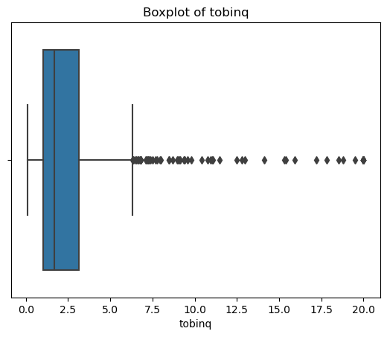

Fig1.2.1 ‘tobinq’ boxplot

The data is right skewed. The missing values in ‘tobinq’ are treated by median imputation. Median imputation is preferred when the distribution is skewed, as the median is less sensitive to outliers than the mean.

After treating the null values in the data, the data info can be seen as below with no null values.

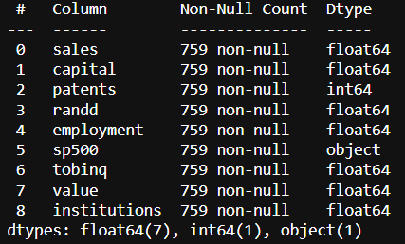

Fig1.2.2 Firm Data Info after null values are treated

### Encode Data

The ‘sp500’ feature is the only categorical feature and contains binary values. After one-hot encoding, the dataset looks like below.

Fig1.2.2.1 Firm Data after encoding

The dataset types are as below after the encoding:

Fig1.2.2.2 Firm Data after converting datatype

### Outliers

The boxplot is plotted to visualize the outliers in all numerical features i.e. except ‘sp500’ which is essentially binary/categorical feature.

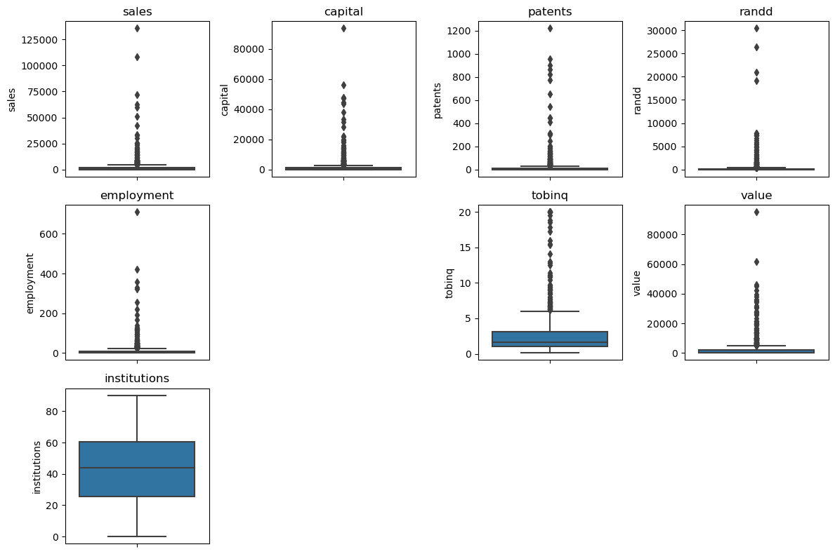

Fig1.2.3.1 Firm Data Boxplot showing outliers

There are multiple outliers in many columns as shown in above plot.

The black dots in the boxplots show that there are multiple outliers in multiple columns. Except 'institutions' remaining features have outliers. Majority of the variables are highly skewed as well and this can be seen in the boxplots as significantly larger tails with large magnitude (Y value).

Treat outliers:

All the outliers are treated by adjusting them to the lower and upper bound values calculated by the IQR value.

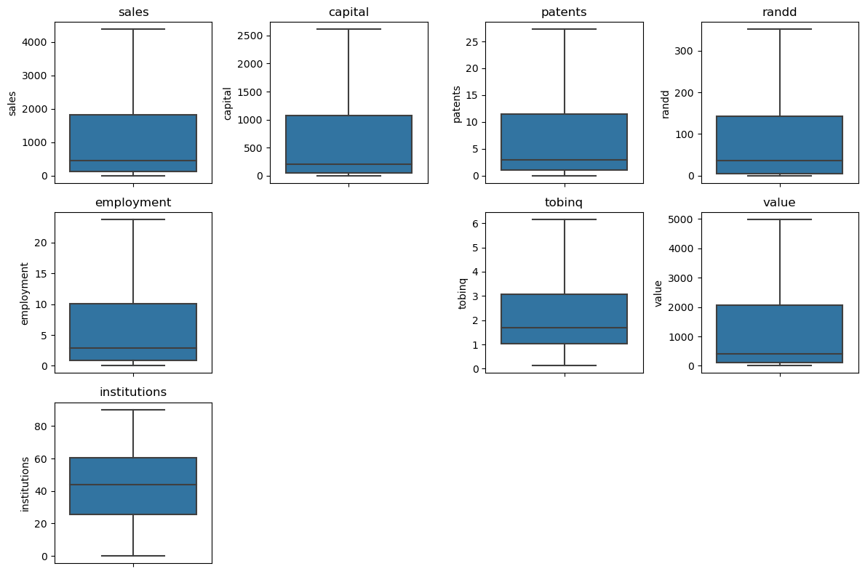

Fig1.2.3.2 Firm Data Boxplot after treating outliers

The above boxplot is after treating the outliers showing no outliers.

### Co-relation

4 co-relation heat maps are shown in this section. These are heatmaps of independent features , heatmaps of all features before and after treating outliers.

Before treating outliers:

The below plot shows the correlation between all variables before outliers are treated:

Fig1.2.4.1 Heatmap – of all variables  
The below plot shows the correlation between independent variables before outliers are treated.

Fig1.2.4.2 Heatmap – of independent variables - before outliers

Below chart shows there is lots of multi-collinearity and co-relation between variables after treating the outliers.

Fig1.2.4.3 Heatmap – of all variables - after treating outliers

The below heatmap shows the co-relation matrix of independent variables:

Fig1.2.4.4 Heatmap – of independent variables - after treating outliers

Based on the above correlation matrix plot:

There are several strong and moderate positive correlations, indicating that certain variables tend to move together in a positive direction. For example, ‘capital’ shows strong positive correlations with ‘patents’, ‘randd’, and ‘employment’.

'tobinq', 'institutions' are weakly co-related. 'patents', 'randd', 'sp500' are moderately co-realted with values around .6/.7. 'capital', 'employment', 'value' are highly co-related with correlation values over .91.

'value' shows moderate positive correlations with multiple variables, indicating potential associations with those variables. The variable 'institutions' generally has weak positive correlations with other variables.

The variable 'tobinq' has weak negative correlations with several other variables, suggesting a weak inverse relationship.

There is high co-relation between the independent variables. This needs to be addressed. It's important to note that correlation alone does not imply causation. Further analysis and domain knowledge are needed to determine the underlying relationships and causality between variables.

### Scaling

The below snap shows the data description after the data is prepared.  
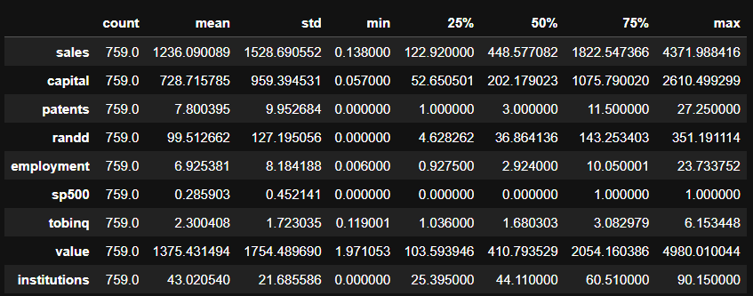

Fig1.2.5.1 Firm Data after scaling

Scaling - Magnitude Differences:

The variables in the dataset have significantly different scales. For example, 'sales' and 'value', 'capital' have much larger magnitudes compared to 'patents', 'employment', and 'institutions'. Scaling can help to ensure that all features contribute equally to the model.

That being said, it is not necessary to perform scaling on the data. In the later sections, ols regression model and linear regression model are fit on the original and scaled data. The models show no major difference in terms of performance metrics.

## Create Models

Encode the data (having string values) for Modelling. Is Scaling necessary here or not?( 2 pts), Data Split: Split the data into train and test (70:30) (2 pts). The learner is expected to check and comment about the difference in scale of different features on the bases of appropriate measure for example std dev, variance, etc. Should justify whether there is a necessity for scaling. Object data should be converted into categorical/numerical data to fit in the models. (pd.categorical().codes(), pd.get_dummies(drop_first=True)) Data split, ratio defined for the split, train-test split should be discussed.

Answer:

### Split Data

The ‘sales’ feature is the target variable, y. Rest of the data is X. Using sklearn train_test_split feature, the data X and y is split into train and test sets in a 70:30 ratio.

Train Test Data for the Stats Model:

The Train dataset top 5 rows are shown below.

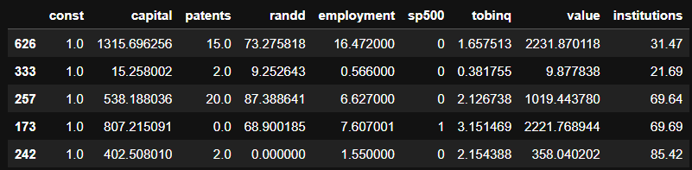

The test dataset top 5 rows are shown below.

The training and test dataset sample for stats model **after scaling** is shown below:

#### VIF (Variance Inflation Factor)

The below snap the sorted features by Importance of the sm ols original train dataset.

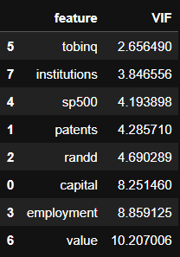

Fig1.3.1.1.1 Variance Inflation Factor on ols train dataset

Below snap shows the sorted features by VIF importance of the sms ols scaled train dataset.

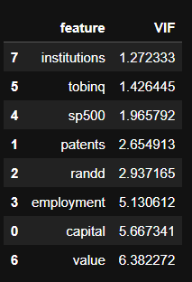

Fig1.3.1.1.2 Variance Inflation Factor on scaled ols train dataset

In both cases, ‘employment’, ‘capital’, ‘value’ have high multicollinearity with VIF value > 5. However, dropping variables blindly based on VIF value may not always result in better models.

Using VIF, features with high co-linearity can be identified. For reference, the range of VIF:

|  |  |
| --- | --- |
| VIF | Starts at 1 |
| VIF = 1 | no correlation between this independent variable and the other variables |
| 1 < VIF < 5 | Indicates moderate collinearity |
| VIF > 5 | exceeding 5 or 10 indicates high multicollinearity between this independent variable and the other. |

Table1 VIF Range

### Model 1 – OLS Initial

OLS Stats Model is fit on the train data. The performance metrics on the initial model are shown as below.

Initial OLS Model Training Set Metrics:

RMSE: 394.33716619028996

R-squared: 0.9359702538559448

Initial OLS Model Test Set Metrics:

RMSE: 400.0021149372728

R-squared: 0.9240311293641787

The summary of the results is as shown below:

The OLS Regression results are as below: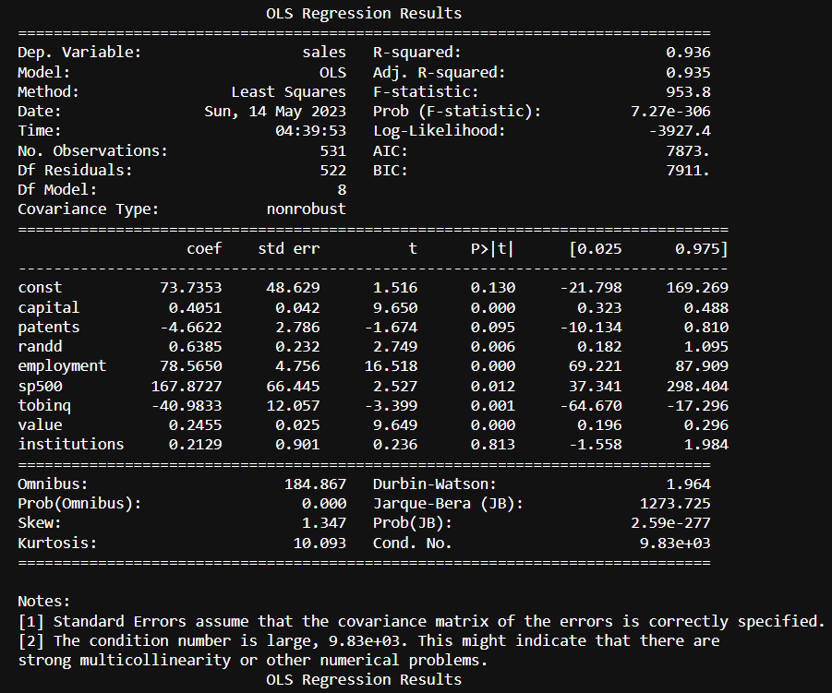

Fig1.3.2 Model 1 – OLS Initial Model

### Model 2 – OLS Dropped p>.05

All features with p values above .05 are dropped and the new model regression performance metrics are:

Training Set Metrics:

RMSE: 395.3975671797366

R-squared: 0.9356254296687838

Test Set Metrics:

RMSE: 398.4877494359508

R-squared: 0.9246052606459508

And the summary of result is as shown below.

Fig1.3.3 Model 2 – OLS Model dropped p>.05

The model assumptions, such as normality and absence of autocorrelation, should be carefully evaluated.

### Model 3 – OLS Scaled Data

The performance metrics on the OLS Scaled data are as below:  
  
Scaled Model Training Set Metrics:  
RMSE: 394.33716619028996  
R-squared: 0.9359702538559448

Scaled Model Test Set Metrics:  
RMSE: 400.002114937273  
R-squared: 0.9240311293641786

regression result on scaled data are as shown below:  
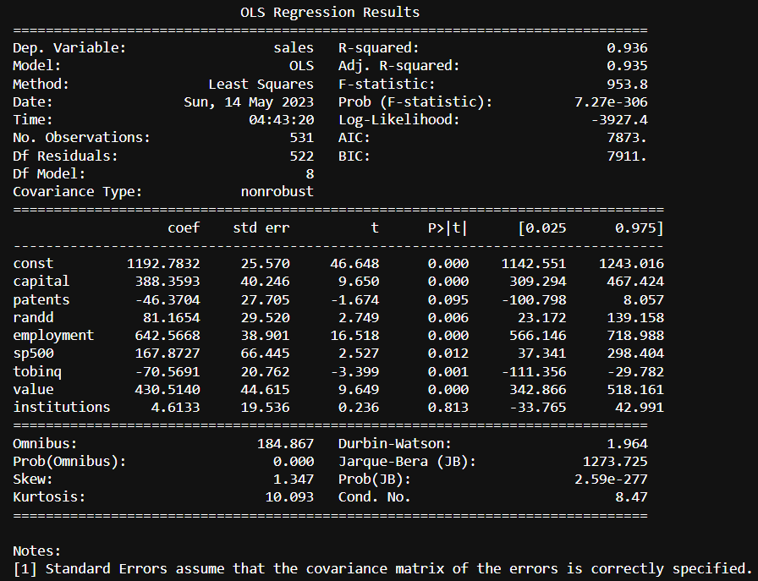

Fig1.3.4 Model 3 – OLS Initial Model on scaled data

### Model 4 – OLS Scaled and refined

The scaled and new model after dropping all features with p>0.05 has below metrics:  
Scaled Improved Model Training Set Metrics:

RMSE: 395.3975671797366

R-squared: 0.9356254296687838

Scaled Improved Model Test Set Metrics:

RMSE: 398.48774943595146

R-squared: 0.9246052606459505

The complete summary is as shown below:

Fig1.3.4 Model 4 – OLS Model on scaled data dropped p>.05

### Model 5 – OLS Data – dropping variables

Blindly dropping all features above p>0.05 is not always correct as the dropped features may have multi-coliinearity but still carry important information about the target variable. So instead, drop each variable based on p-value, lower rmse, higher r-squared, Higher F-Statistic. This is iterative process and in the final improved model 'sales','patents','institutions','randd' are dropped.

The OLS Stats improved regression model equation can be given as below:

y = (81.7013 * const) + (0.4118 * capital) + (80.6845 * employment) + (176.4655 * sp500) - (39.6549 * tobinq) + (0.2466 * value)

1. When all other predictors are zero, the const is 81.703 which is not bad.
2. for a one-unit increase in the "sp500" variable, holding all other variables constant, the sales price increases by 176.4655
3. For one-unit increase in ‘tobinq’ the sales decreases by -39.6549 as the ‘-‘ sign indicates an inverse relationship.

The performance metrics and the summary of this improved ols model are as below:

Training Set Metrics:

RMSE: 397.20671726067104

R-squared: 0.935034987496708

Test Set Metrics:

RMSE: 394.38620894692014

R-squared: 0.9261493138182268

Performance metrics on test data-

1. An R-squared value of 0.926 suggests that the model explains approximately 92.6% of the variance in the sales data.
2. The RMSE for the test set indicates the average deviation of the predicted sales values from the actual sales values in the test set. A lower RMSE is desirable, indicating better predictive performance. The RMSE of 394.38 suggests an average deviation of approximately 398.488 which is pretty good considering the target variable range.
3. The target variable has a mean of 2689.705158 and a standard deviation of 8722.060124. In this context, an RMSE of 394 is relatively small compared to the magnitude of the target variable. It indicates that, on average, the model's predictions have an error of approximately 394 units, which is relatively low compared to the overall scale of the target variable. Hence, this is an acceptable value of RMSE.

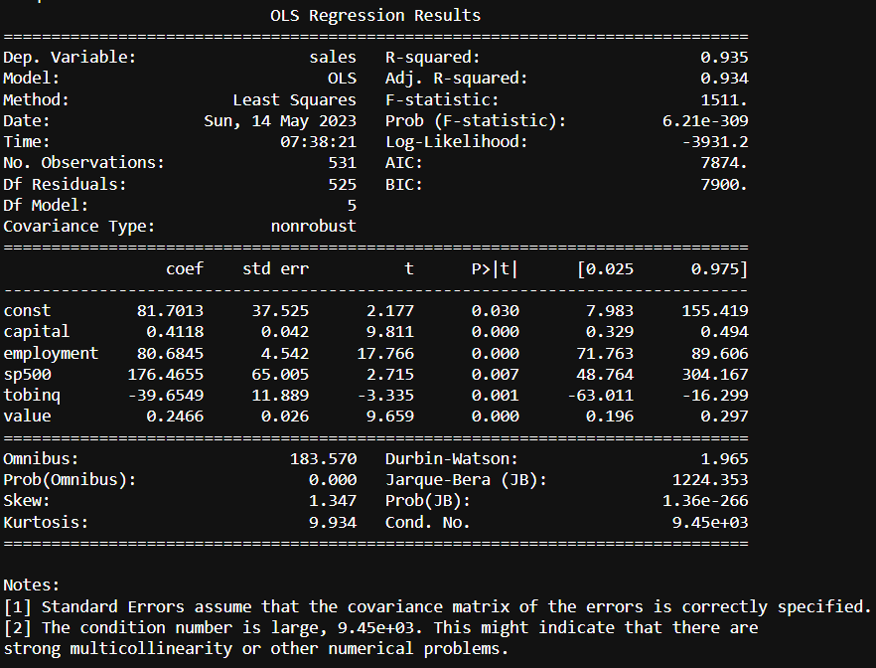

Fig1.3.6 Model 5 - OLS Improved model

### Model 6 – Simple Linear Regression

Below are the Lienar regression results:

Coefficients: [[ 0.40506319 -4.66215536 0.63853807 78.56497068 167.87266108

-40.98329451 0.24554026 0.21287606]]

Intercept: [73.73534908]

----

Training set performance:

RMSE: 394.337

R-squared: 0.936

MSE 155501.80063898838

Test set performance:

RMSE: 400.002

R-squared: 0.924

MSE 160001.69195429183

#### Actual v predicted scatter plot

Fig1.3.7.1 Scatter Plot- Actual v Predicted Sales for OLS Stats model.

The above scatter plot shows between actual and predicted values. Inferences are:

1. There are 3 areas, one where the sales are below ‘1000’, between ‘1000-2000’ & higher.
2. The model correctly predicts level 1, whereas the variance increases as the sales value increases.
3. The variance of the error is not constant across various levels of your dependent variable.

#### Residual plot

Fig1.3.7.2 Residual Plot OLS Stats Model

1. The residual points are symmetrically distributed, tending to cluster towards the middle of the plot.
2. They’re clustered around the lower single digits of the y-axis.
3. In general, there aren’t any clear patterns.
4. This is an ideal residual plot and is acceptable.

Note- Scatter plots and residual plots for all models have been plotted and all show similar result.

### Model 7 – Linear Regression on Scaled Data

Model performance results are:

Coefficients: [[388.35931937 -46.37038134 81.16536349 642.56680013 167.87266108

-70.56912892 430.5139761 4.61330005]]

Intercept: [1192.78318419]

----

Training set performance:

RMSE: 394.337

R-squared: 0.936

MSE 155501.8006389884

Test set performance:

RMSE: 400.002

R-squared: 0.924

MSE 160001.69195429125

### Model 8 – Linear Regresion on Scaled data- dropping features over VIF 5

Model performance results are:

Coefficients: [[ 21.6288429 429.0632531 2050.9331315 -246.32957 54.98948947]]

Intercept: [669.99885843]

----

Training set performance:  
RMSE: 854.696

R-squared: 0.699

MSE 730504.8254082266

Test set performance:

RMSE: 948.881

R-squared: 0.573

MSE 900375.8143274568

### Scikit learn Linear Models Discussion & Equation

Below is the discussion on Scikit learn’s linear models:

1. As discussed above, and based on the Model 6,7,8 results, scaling does not necessary give drastic results in this dataset. The Model 6, 7 have similar or same performance result upto or above 5 decimal points.
2. The best linear model is Model 6 – Simple Linear regression without scaling.
3. Linear regression can be given by below equation (Model 6 – Simple Linear Regression):

y = 0.40506319 * capital - 4.66215536 * patents + 0.63853807 * randd + 78.56497068 * employment + 167.87266108 * sp500 - 40.98329451 * tobinq + 0.24554026 * value + 0.21287606 * institutions + 73.73534908

1. Dropping features, blindly based on VIF value may not give better model. Infact, as seen in model 8, the model may show decrease in predicting performance.

### Compare Scikit learn and OLS model – Model 5, Model 6

1. Scikit learn gives Test set performance of RMSE: 400.002, R-squared: 0.924
2. Stats model gives test set performance of RMSE: 394.38620894692014, R-squared: 0.9261493138182268
3. Both models are strong models for regression. However, Stats model is slightly a better model compared to scikitlearn.

## Inference

Apply Logistic Regression and LDA (Linear Discriminant Analysis) (2 pts). Interpret the inferences of both model s (2 pts). Successful implementation of each model. Logical reason should be shared if any custom changes are made to the parameters while building the model. Calculate Train and Test Accuracies for each model. Comment on the validness of models (over fitting or under fitting)

Answer:

1. There might still be multicollinearity which needs to be addressed with business team.
2. Stats model is used for model prediction given equation y = (81.7013 * const) + (0.4118 * capital) + (80.6845 * employment) + (176.4655 * sp500) - (39.6549 * tobinq) + (0.2466 * value)
3. ‘capital’, ‘employment’, ‘tobinq’, ‘value’, ‘sp500’ are the best predictors of the target variable.
4. ‘institutions’, ‘patents’, ‘raandd’ do not show a significance value in predicting the target variable. However, this does not mean they are poor predictors.
5. Focus on Capital Investment - as this variable has a high positive impact on ‘sales’
6. Monitor S&P 500 Performance: The coefficient of the "sp500" variable is 176.4655. This indicates that the performance of the S&P 500 index has a positive impact on the response variable. It is recommended to closely monitor the trends and movements of the S&P 500 index as it can potentially influence the ‘sales’ outcome.
7. ‘tobinq’ has an inverse relationship and the company should evaluate this variable carefully as this has a negative effect on the ‘sales’.

## Apply KNN

Apply KNN Model and Naïve Bayes Model (2pts). Interpret the inferences of each model (2 pts). Successful implementation of each model. Logical reason should be shared if any custom changes are made to the parameters while building the model. Calculate Train and Test Accuracies for each model. Comment on the validness of models (over fitting or under fitting).

Answer:

## Model Tuning

Model Tuning (4 pts) , Bagging ( 1.5 pts) and Boosting (1.5 pts). Apply grid search on each model (include all models) and make models on best_params. Compare and comment on performances of all. Comment on feature importance if applicable. Successful implementation of both algorithms along with inferences and comments on the model performances

Answer:

## Perormance Metrics

Performance Metrics: Check the performance of Predictions on Train and Test sets using Accuracy, Confusion Matrix, Plot ROC curve and get ROC_AUC score for each model, classification report (4 pts) Final Model - Compare and comment on all models on the basis of the performance metrics in a structured tabular manner. Describe on which model is best/optimized, After comparison which model suits the best for the problem in hand on the basis of different measures. Comment on the final model.(3 pts)

Answer:

## business report

Based on your analysis and working on the business problem, detail out appropriate insights and recommendations to help the management solve the business objective. There should be at least 3-4 Recommendations and insights in total. Recommendations should be easily understandable and business specific, students should not give any technical suggestions. Full marks should only be allotted if the recommendations are correct and business specific.

Answer:

# Problem 2: Text Analysis

In this problem, we are going to work on the ‘inaugural’ corpus from ‘nltk’. From the ‘inaugural’ corpus, we will be looking at the following speeches of the Presidents of the United States of America:

1. President Franklin D. Roosevelt in 1941
2. President John F. Kennedy in 1961
3. President Richard Nixon in 1973

## Data Description

Dataset for Problem 2 is [Speeches](https://olympus.mygreatlearning.com/courses/87097/files/8138792/download?verifier=kcQ6RT3tCQerAz9MVJy0NXx1x1ip6h333DQmO57Y&wrap=1). Data Description is given below:

1. ‘NLTK’ has 'inaugural' corpus that contains the inaugural speeches given by U.S.A Presidents.
2. In the project we are working with *three* different inaugural speeches from the nltk ‘inaugural’ corpus : the speech by Franklin D. Roosevelt in 1941, the speech by John F. Kennedy in 1961, and the speech by Richard Nixon in 1973 which will be the corpus for our project.
3. The corpus contains the raw text of the specified speeches.

## Exploratory Data Analysis

Find the number of characters, words and sentences for the mentioned documents. (Hint: use .words(), .raw(), .sent() for extracting counts).

Answer:

### Sample Data

Using nltk’s ‘sent_tokenize’, the sample 3 sentences of each president’s speeches are extracted. The sample sentences are as below:

Sample sentences of Roosevelt's Speech:

1. 'On each national day of inauguration since 1789, the people have renewed their sense of dedication to the United States.'
2. ‘In Washington's day the task of the people was to create and weld together a nation.’
3. ‘In Lincoln's day the task of the people was to preserve that Nation from disruption from within.’

Sample sentences of Kennedy's Speech:

1. ‘Vice President Johnson, Mr. Speaker, Mr. Chief Justice, President Eisenhower, Vice President Nixon, President Truman, reverend clergy, fellow citizens, we observe today not a victory of party, but a celebration of freedom -- symbolizing an end, as well as a beginning -- signifying renewal, as well as change.’
2. 'For I have sworn I before you and Almighty God the same solemn oath our forebears l prescribed nearly a century and three quarters ago.'
3. 'The world is very different now.'

Sample sentences of Nixon's Speech:

1. ‘Mr. Vice President, Mr. Speaker, Mr. Chief Justice, Senator Cook, Mrs. Eisenhower, and my fellow citizens of this great and good country we share together:\n\nWhen we met here four years ago, America was bleak in spirit, depressed by the prospect of seemingly endless war abroad and of destructive conflict at home.'
2. 'As we meet here today, we stand on the threshold of a new era of peace in the world.'
3. 'The central question before us is: How shall we use that peace?'

Inference: Roosevelt starts with the historical tradition. Kennedy’s starts with celebration and a change. Nixon speech is formal and is about reality of nation.

### Data Statistical Description

Text analysis is performed on the raw data and below is the summary of number of characters, number of words, number of sentences from each president’s speech (Data cleanup is not performed yet):

1941-Roosevelt.txt:

No. of Characters: 7571

No. of Words: 1536

No. of Sentences: 68

1961-Kennedy.txt:

No. of Characters: 7618

No. of Words: 1546

No. of Sentences: 52

1973-Nixon.txt:

No. of Characters: 9991

No. of Words: 2028

No. of Sentences: 69

### Univariate Analysis

Nltk’s ‘word_tokenize’ is used to tokenize the words from raw speech. Data cleanup is done without stemming or lemmatization to get first-idea of how data is.

Using nltk’s standard ‘stopwords’, the stopwords from the speeches are removed. Only words are considered and then lowercase is implemented on all words from the 3 speeches. Now, a barchat is plotted on top 5 frequent words from each speech. The visualization is shown below:

## Prepare Data for wordcloud

Remove all the stopwords from the three speeches. Show the word count before and after the removal of stopwords. Show a sample sentence after the removal of stopwords.

Answer:

### Stopwords

‘Stopwords’ are downloaded from the nltk package and the standard ‘english’ language stopwords are used to clean the data. Punctuation are cleaned from the data. Numbers are used rarely in the these 3 speeches, however all numbers are also removed from the data.

The below summary shows the count of words before and after removing stopwords/punctuation/numbers from the text:

Roosevelt words count before and after removing stopwords are : 1536 & 632 resepctively.

Kennedy words count before and after removing stopwords are : 1546 & 697 resepctively.

Nixon words count before and after removing stopwords are : 2028 & 836 resepctively.

Roosevelt words count before and after removing stopwords are : 1536 & 627 resepctively.

Kennedy words count before and after removing stopwords are : 1546 & 692 resepctively.

Nixon words count before and after removing stopwords are : 2028 & 832 resepctively.

Below are the sample sentence from each president’s speech after removing the stopwords & puinctuation & numbers:

Sample sentence after removing stopwords (1941-Roosevelt.txt):

national day inauguration since people renewed sense dedication united states washington day task people create weld together nation lincoln day

Sample sentence after removing stopwords (1961-Kennedy.txt):

vice president johnson mr speaker mr chief justice president eisenhower vice president nixon president truman reverend clergy fellow citizens observe

Sample sentence after removing stopwords (1973-Nixon.txt):

mr vice president mr speaker mr chief justice senator cook mrs eisenhower fellow citizens great good country share together met

### Lemmatization

Standard ‘WordNetLemmatizer’ from the nltk.stem is used. Below is a sample of the words.

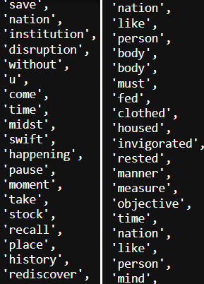

Verbs are not reduced to the base form. Words like ‘us’ are reduced to ‘u’ as they were considered as plural. These are shown in figure below.  
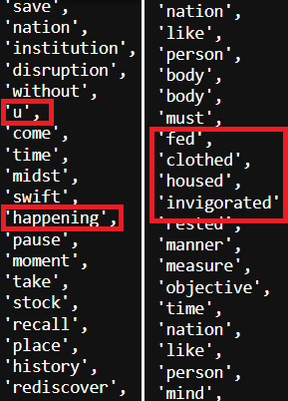

Observation from standard lemmatization:

1. 'Us' does not have to be lemmatized as 'u' and a rule can be added to skip lemmatizing 'us', thus preserving the word.
2. Roman Numbers are used like ‘ii’ from the ‘world war 2’. Since in this specific example, the frequency of such Roman Numbers is minute. those can be ignored for now.
3. The verbs can be lemmatized to base form using 'pos_tag'.

To address above issues, convert the POS tags to WordNet-compatible POS tags. This helps in obtaining the base or dictionary form of the words, which can improve the quality of the lemmatized output.

A sample lemmatized word output from Nixon’s speech looks like this now:

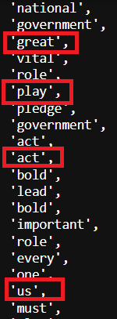

‘Us’ is preserved. Many verbs are now in base form. There is however improvement needed to make sure words like ‘us’ are preserved from original speech. There is also work needed to convert adjectives, adverbs & verbs to base/dictinary form.

## Frequent Words

Which word occurs the most number of times in his inaugural address for each president? Mention the top three words. (after removing the stopwords) 3

Answer:

Top 3 frequent words and the frequency with which the words are repeated is shown in the summary below:

Top 3 words from 1941-Roosevelt.txt:

nation : 15  
life : 10  
know : 10

Top 3 words from 1961-Kennedy.txt:

let : 16  
us : 12  
world : 8

Top 3 words from 1973-Nixon.txt:  
  
us : 26  
let : 22  
america : 21

## Word Cloud

Plot the word cloud of each of the three speeches. (after removing the stopwords) 3

Answer:

Below word cloud visually shows words used for each speech.

Quick look at the wordclous of 3 speeches is below:

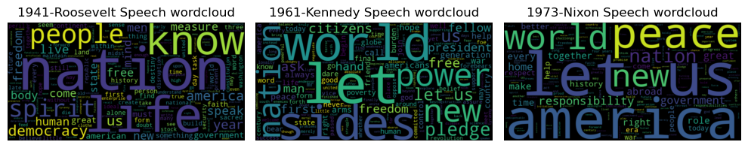

Based on the word cloud, below can be inferred:

Roosevelt’s speech:

* Key words: nation, life, know, people, spirit, democracy, us, year, america, live.
* Roosevelt’s speech talks about the spirit of the nation and the speech inspired the audience to ‘know’, emphasises on ’nation’, ‘spirit’, ‘life’, ‘people’.

Kennedy’s speech:

* Key words: let, us, world, side, power, new, nation, pledge, ask, citizen.
* Insights: The speech seems bold with words like ‘dare’, ‘power’. It calls for collective action for the nation to come together. The speech has an aspirational tone, calling ‘citizens’ to actively participate. Speech seems to set the stage or talk about the ‘new world’ ‘power’.

Nixon’s speech:

* Key words: us, let, america, peace, world, responsibility, new, nation, great, make.
* Highlights ‘world’, ‘peace’ and talks about the desire to make positive impact on world. Especially america’s role in it with words like ‘responsibility’.

The speeches are inline with America’s role, global actions, global policies ever since.

!!! Major note & caution - only so much can be inferred about tone & mood of the speeches from a wordcloud. Deeper analysis with access to history is needed to arrive at a more nuanced and correct inference.

# Reflection Report:

Please reflect on all that you learnt and fill this reflection report. You have to copy the link and paste it on the URL bar of your respective browser. https://docs.google.com/forms/d/e/1FAIpQLScKuVyrmTTM7Pboh0IB4YIBUbJp2NrDZcsY4SCRn3ZUkwmLGg/viewform

<Completed>